Paragragh Structure vs. Essay Structure

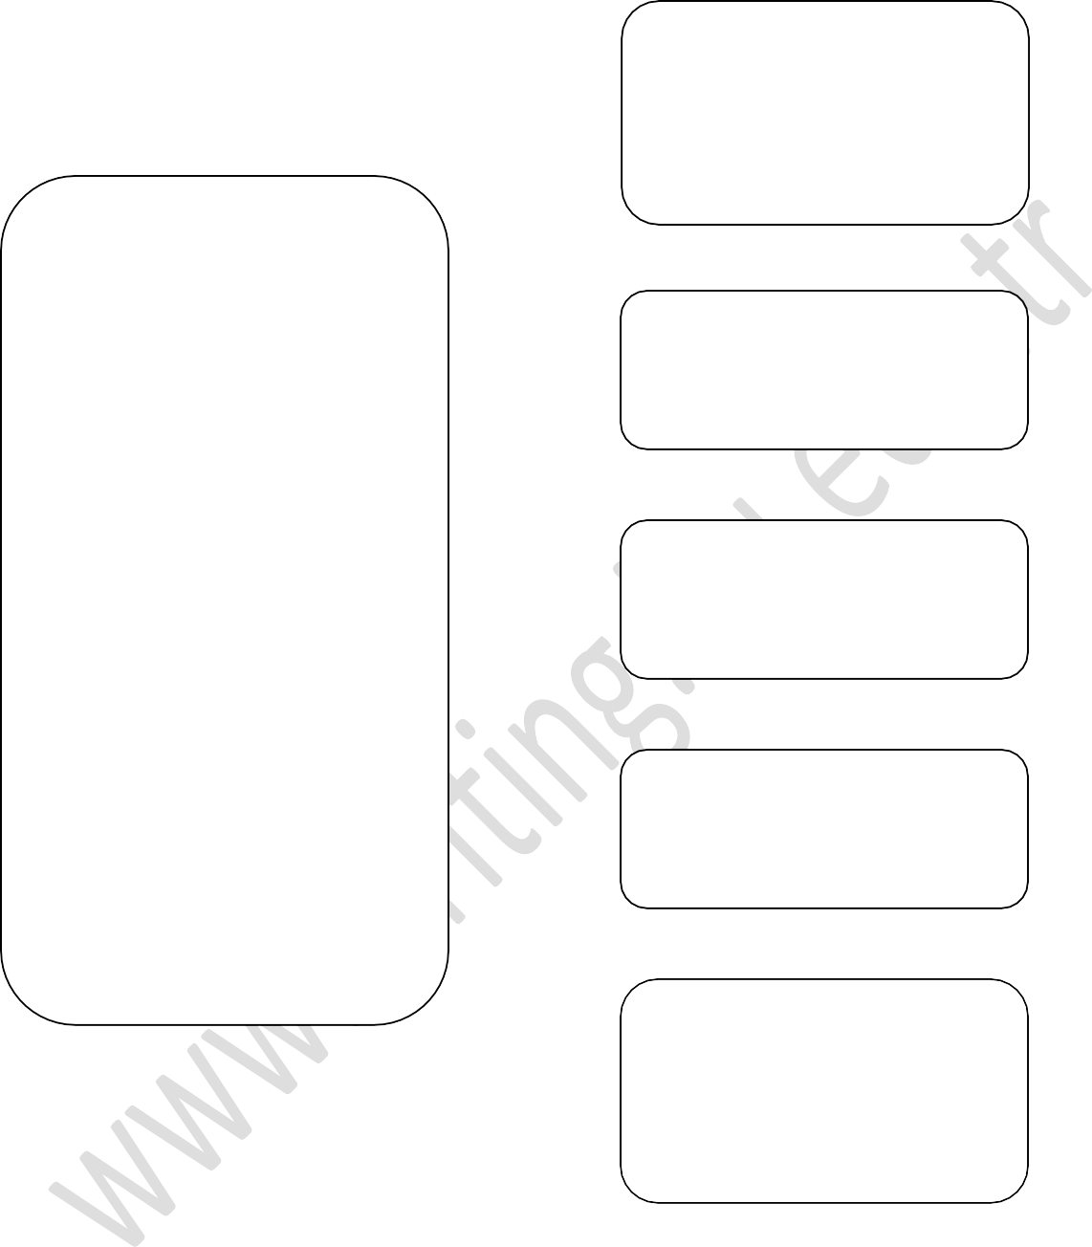
Introduction paragraph
includes:
- general statements
- thesis statement
Topic Sentence
Supporting Idea 1
Supporting Sentences
Supporting Idea 2
Supporting Idea 3
Concluding Sentence
Conclusion paragraph
includes:
- concluding sentence
- final thought

Focus on Essay Structure


Introduction
Introduction
General Statements
Thesis Statement
General Statements

A, B and C
A
A, B and C
Topic Sentence
Thesis Statement

A
Topic Sentence

Body
B
Body
Topic Sentence
Topic Sentence
B
Topic Sentence

C
Topic Sentence

Concluding Sentence
C
Concluding Sentence

Conclusion
Conclusion

Final Thought
Final Thought

Essays generally follow the same basic structure - an introduction, a body and a conclusion. Each section has specific functions that help the essay achieve a strong and coherent argument.

The Introduction Paragraph

The introduction provides a map of the essay and sets up the central argument. The introduction is shaped like an upside - down triangle because it leads the reader from the general views on the analyzed topics to the specific narrow theme of the essay. Therefore, as can be seen from the diagram above, the introductory paragraph consists of two distinct parts: general statements and the thesis statement. As the introduction progresses, it narrows down from general to more specific until reaching the last sentence that clearly states the thesis. A strong thesis statement defines and states the paper’s main idea:
e.g. As more and more people integrate the internet into their work and private lives, we will see a dramatic increase in both written and oral communication skills.
The thesis statement above has TWO clear supporting ideas (topics) which will be explained in the body paragraphs. According to the order of the ideas in the thesis statement the first body paragraph must include the idea “increase in written communication skills”. The second body paragraph must support the idea “increase in oral communication skills”. As can be seen in the diagram above, the order of the ideas in the thesis statement is A, B, C; so the order of the body paragraphs MUST follow the same order A, B, C.
Thus, a good introductory paragraph:
- Introduces the reader to the general topic.
- Provides brief background information about the meaning, context & significance of the topic.
- Gives the reader an understanding of the order in which the ideas in the essay will be presented.
- Clearly identifies the main points in a thesis statement.

The Body Paragraphs
In the diagram the body paragraphs are shaped like rectangles because all the information in these paragraphs concerns one topic, clearly supporting and proving the thesis statement.
Body paragraphs need to directly and specifically discuss the points mentioned in the thesis statement in the order they are given. If this is not done, the essay is not just invalid, it is misleading, and readers will become confused.

Each paragraph should contain only one main idea, as stated by the topic sentence. Make sure paragraphs follow in logical sequence (as given in the Introduction) so that the essay flows towards the conclusion.
A body paragraph takes an idea: “the advantages of using the internet” and discusses it in detail, giving examples and evidence to support that point. The following topic sentences support the thesis statement given in the introduction:
Topic sentence for the first body paragraph:
e.g. Firstly, writing skills naturally improve with internet use, since almost all online communication is conducted through the written word.
Topic sentence for the second body paragraph:
e.g. Secondly, while internet users become more proficient at writing, their spoken communication skills will also improve because writing will give them practice organizing and expressing their ideas.
Thus, a good body paragraph:
- Has only one main idea.
- Follows the order given in the thesis statement.
- Explains the main idea in sufficient detail.

The Conclusion Paragraph
The conclusion paragraph is shaped like a triangle because it contains two parts:
The first part, concluding sentence, contains specific information, reversing the structure of the introduction through restating what the thesis proved or summarizing what has been said in the body paragraphs of the essay.

The second part, final thought, broadens the focus of the essay until closing it with a strong final statement providing the reader with a relevant prediction, suggestion, advice or warning.
The purpose of the conclusion is to bring the essay to a satisfying close and remind the reader of the main points. The conclusion paragraph should not introduce any new points. The following concluding sentence restates the thesis statement given in the introduction:
e.g. To conclude, both written and spoken communication skills can be improved through the widespread use of the internet at home, at school and at work.
Thus, a good concluding paragraph:
- Sums up the main points or states the thesis statement in different words.
- Comments or makes recommendations for further discussion of topic.
- Avoids adding new material.

USEFUL VOCABULARY

Connectors should be used to make the essay easier to understand.


To Show the Order of the Ideas:

To start with,
To begin with,
First, | Second, | Third, | Also,
First of all, | Secondly, | Thirdly, | In addition,
Firstly,
To Show Additional Ideas:
Besides, Moreover, also, In addition, Furthermore

To Show Examples:
For instance, For example, To illustrate,

To Show Conclusion:
To conclude, In conclusion,
To sum up, To summarize, In summary, In short, In brief,



The sample shows essay organization

The Role of Computers in Modern Society
Throughout human existence, man has strived to develop and use new and more beneficial tools in order to improve his standard of living. The modern computer is the most recent of these life changing tools. In existence for only a few decades, personal computers have had a major impact on modern society, especially in the fields of commerce and education. It is now impossible to imagine engaging in business or learning activities without computers. Being a major part of everyday life, the computer has totally changed the way we work and the way we study.
Thesis Statement
General Statements
To start with, the speed and memory capacity of computers have changed the business world. The business world has become increasingly competitive, with speed of the utmost importance. Before computers, tasks such as book-keeping, liaising with clients, suppliers and manufacturers and filing information were time-consuming and inefficient. Furthermore, nowadays software has revolutionised accounting practice, electronic messages are transmitted across the globe in seconds, and countless millions of bytes of data can be stored and accessed almost immediately.
Topic Sentence

Secondly, education has also benefited from the computer’s ability to manage vast amounts of information. Scientists and scholars use computers for calculations and simulation programs that would have been impossible in the past. In addition, students use computers and in particular the internet to research and gather information for projects much more quickly than in the past. Moreover, students can engage in self study programs, learn together with students from around the world or use computers to study at home.
Topic Sentence

To conclude, computers undoubtedly make a significant contribution in terms of business activities and educational conditions. The computer has been and continues to be one of the most important and influential inventions of all humankind. The future of humankind is now a history which includes the computer.
Concluding Sentence
Final Thought

Adapted from www.victoria.ac.nz/st_services/slss/studyhub.aspx

www.apurnell.com/cs1readings/ElementsAndStructure.htm

The sample shows essay connectors


The Role of Computers in Modern Society
Throughout human existence, man has strived to develop and use new and more beneficial tools in order to improve his standard of living. The modern computer is the most recent of these life changing tools. In existence for only a few decades, personal computers have had a major impact on modern society, especially in the fields of commerce and education. It is now impossible to imagine engaging in business or learning activities without computers. Being a major part of everyday life, the computer has totally changed the way we work and the way we study.

To start with, the speed and memory capacity of computers have changed the business world. The business world has become increasingly competitive, with speed of the utmost importance. Before computers, tasks such as book-keeping, liaising with clients, suppliers and manufacturers and filing information were time-consuming and inefficient. Furthermore, nowadays software has revolutionised accounting practice, electronic messages are transmitted across the globe in seconds, and countless millions of bytes of data can be stored and accessed almost immediately.
Secondly, education has also benefited from the computer’s ability to manage vast amounts of information. Scientists and scholars use computers for calculations and simulation programs that would have been impossible in the past. In addition, students use computers and in particular the internet to research and gather information for projects much more quickly than in the past. Moreover, students can engage in self study programs, learn together with students from around the world or use computers to study at home.

To conclude, computers undoubtedly make a significant contribution in terms of business activities and educational conditions. The computer has been and continues to be one of the most important and influential inventions of all humankind. The future of humankind is now a history which includes the computer.

Adapted from www.victoria.ac.nz/st_services/slss/studyhub.aspx

www.apurnell.com/cs1readings/ElementsAndStructure.htm

